

COVER SHEET
INDIVIDUAL/GROUP ASSIGNMENT /CASE STUDY/ MINI PROJECT
SEMESTER <SPRING/SUMMER/FALL 20YY>

Student Name (s)* | Abdullah Rashid Almndhari
Student ID (s)* | 23F24274
Module Code* | COMP 20014.1
Module Name* | advanced programming
Session* | B
Submitted to Teacher and Department*
Coursework No.* | Coursework 1 / Coursework 2 / Coursework 3
Assignment Title | IN SEMESTER (INDIVIDUAL) ASSIGNMENT
Actual Word Count (Excluding Cover Page, TOC/Index, references and appendices)
(Fields marked with * are mandatory)

TABLE OF CONTENTS
1. Introduction
2. Task 1: Database
3. Task 2: Client-Side Program
4. Task 3: Server-Side Program
5. Task 4: Utility Class Menu Program
6. Task 5: MOOC Reflection
7. References

INTRODUCTION
This is a Java client server billing system used by CampusConnect Oman. This billing system will generate bills of students for their service charges which include meal delivery services, transport booking services, printing services, ticket booking for events, and study room booking. Discount will be made on basis of scholarship status, age, and priority. Bill generated with expected delivery time will then be returned to the client.
Technologies employed in developing this project include Java Networking with socket and serversocket, multithreading, JDBC, and java collection utility class.

TASK 1: DATABASE
A MySQL database named campusconnect_db is used. It contains a Student table for student details and a Service table for service information. The SQL script also inserts five sample student records and five service records for testing.
Table | Fields | Purpose
Student | id, name, age, scholarship_type | Stores student information needed for billing rules.
Service | service_code, description, base_fee | Stores service descriptions and base fees.
Database creation and insertion SQL:
--creates database if not already exist
CREATE DATABASE IF NOT EXISTS campusconnect_db;
USE campusconnect_db;
--delete tables if already exist in the database
DROP TABLE IF EXISTS Service;
DROP TABLE IF EXISTS Student;
--create student table
CREATE TABLE Student (
id INT PRIMARY KEY,
name VARCHAR(80) NOT NULL,
age INT NOT NULL,
scholarship_type VARCHAR(40) NOT NULL
);
--create servise table
CREATE TABLE Service (
service_code VARCHAR(10) PRIMARY KEY,
description VARCHAR(80) NOT NULL,
base_fee DECIMAL(8,2) NOT NULL
);
--insert data into student table
INSERT INTO Student (id, name, age, scholarship_type) VALUES
(1001, 'Aisha Al Balushi', 18, 'Dean''s List'),
(1002, 'Mohammed Al Hinai', 21, 'Economically Weak'),
(1003, 'Sara Al Riyami', 24, 'Employee Special Support'),
(1004, 'Khalid Al Mukhaini', 20, 'Dean''s List'),
(1005, 'Fatma Al Harthy', 25, 'Economically Weak');
--insert data into service table
INSERT INTO Service (service_code, description, base_fee) VALUES
('FD100', 'Food Delivery', 2.50),
('TR200', 'Transport Booking', 4.00),
('PR300', 'Printing Service', 1.50),
('EV400', 'Event Ticket Booking', 6.00),
('ST500', 'Study Room Booking', 3.50);
--selecting data from tables
SELECT * FROM Student;
SELECT * FROM Service;
Screenshot placeholders to replace before submission:
Evidence | Screenshots
Database creation screenshot | 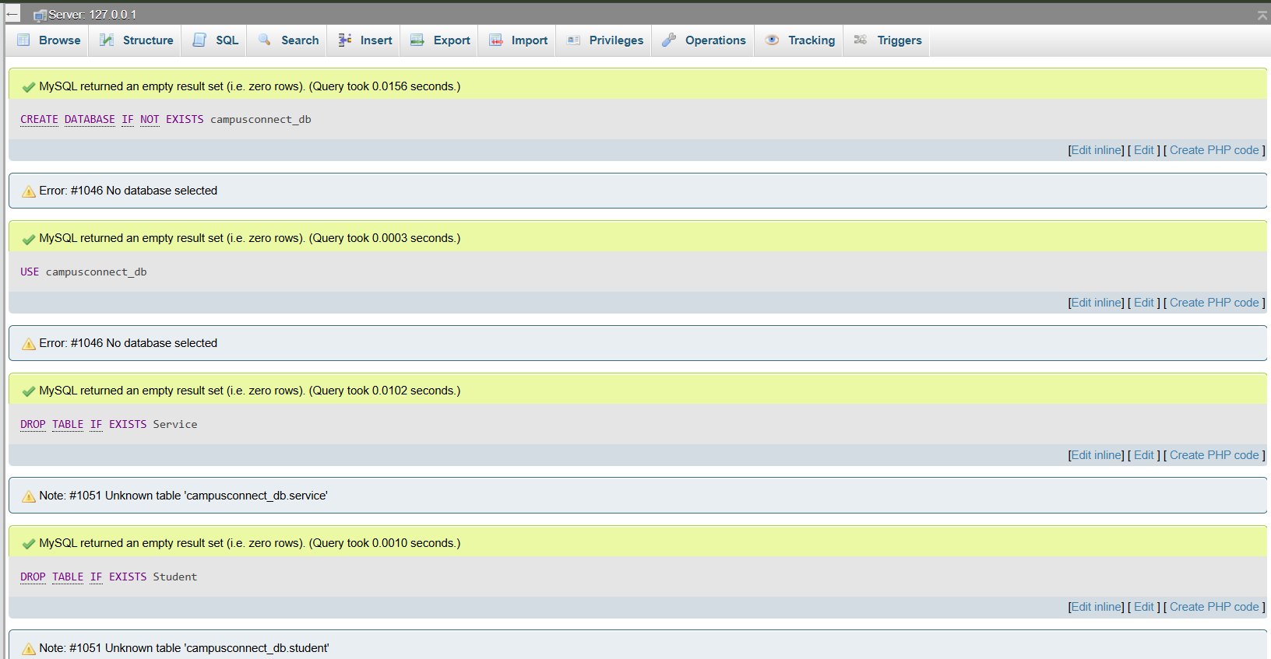
Student table creation screenshot | 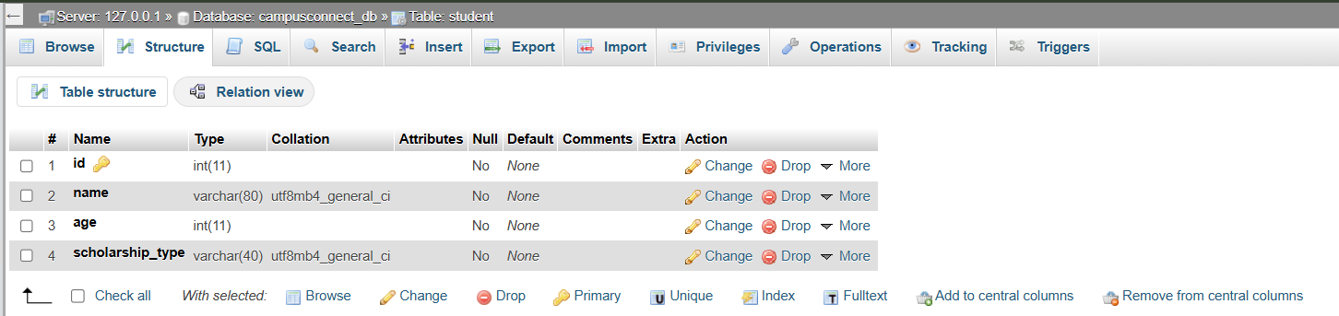
Service table creation screenshot | 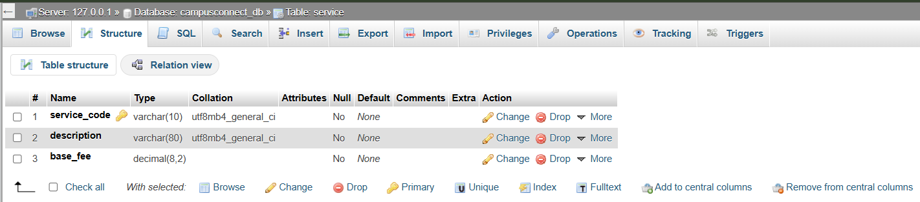
Record insertion screenshot | 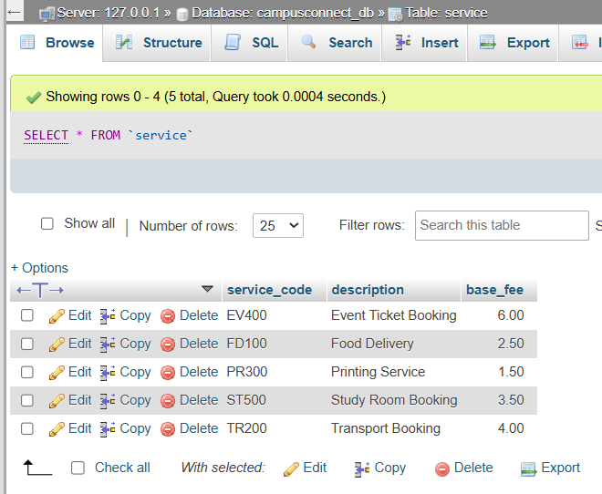  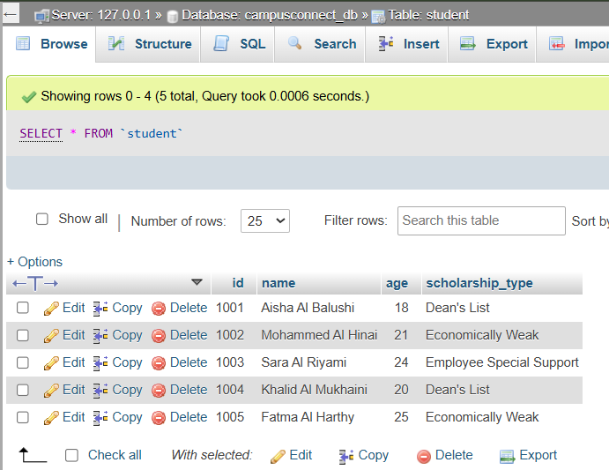

TASK 2: CLIENT-SIDE PROGRAM
The client-side program uses a Runnable class so that the client logic can run in a separate thread. It accepts the student id, service code, and priority type from the user. It validates each input before creating a serializable BillingRequest object and sending it to the server through an ObjectOutputStream.
Client thread, validation, connection, send, receive, and display:
package campusconnect.client;
import campusconnect.common.BillingRequest;
import campusconnect.common.BillingResponse;
import java.io.ObjectInputStream;
import java.io.ObjectOutputStream;
import java.net.Socket;
import java.util.Scanner;
public class ClientWorker implements Runnable {
private static final String SERVER_HOST = "localhost";
private static final int SERVER_PORT = 5000;
@Override
public void run() {
try (Scanner scanner = new Scanner(System.in)) {
int studentId = readStudentId(scanner);
String serviceCode = readServiceCode(scanner);
String priorityType = readPriorityType(scanner);
BillingRequest request = new BillingRequest(studentId, serviceCode, priorityType);
try (Socket socket = new Socket(SERVER_HOST, SERVER_PORT);
ObjectOutputStream output = new ObjectOutputStream(socket.getOutputStream());
ObjectInputStream input = new ObjectInputStream(socket.getInputStream())) {
output.writeObject(request);
output.flush();
BillingResponse response = (BillingResponse) input.readObject();
displayResponse(response);
}
} catch (Exception exception) {
System.out.println("Client error: " + exception.getMessage());
}
}
private int readStudentId(Scanner scanner) {
while (true) {
System.out.print("Enter student id: ");
String value = scanner.nextLine().trim();
try {
int id = Integer.parseInt(value);
if (id > 0) {
return id;
}
System.out.println("Student id must be a positive number.");
} catch (NumberFormatException exception) {
System.out.println("Invalid id. Please enter digits only.");
}
}
}
private String readServiceCode(Scanner scanner) {
while (true) {
System.out.print("Enter service code (FD100/TR200/PR300/EV400/ST500): ");
String code = scanner.nextLine().trim().toUpperCase();
if (code.matches("FD100|TR200|PR300|EV400|ST500")) {
return code;
}
System.out.println("Invalid service code. Try again.");
}
}
private String readPriorityType(Scanner scanner) {
while (true) {
System.out.print("Enter priority type (Normal/Express): ");
String priority = scanner.nextLine().trim();
if (priority.equalsIgnoreCase("Normal") || priority.equalsIgnoreCase("Express")) {
return priority.substring(0, 1).toUpperCase() + priority.substring(1).toLowerCase();
}
System.out.println("Priority type must be Normal or Express.");
}
}
private void displayResponse(BillingResponse response) {
if (!response.isSuccess()) {
System.out.println("Server message: " + response.getMessage());
return;
}
System.out.println("\nCampusConnect Oman Billing Result");
System.out.println("--------------------------------");
System.out.println("Student ID: " + response.getStudent().getId());
System.out.println("Student Name: " + response.getStudent().getName());
System.out.println("Age: " + response.getStudent().getAge());
System.out.println("Scholarship Type: " + response.getStudent().getScholarshipType());
System.out.println("Service: " + response.getService().getDescription());
System.out.printf("Service Amount: %.2f OMR%n", response.getService().getBaseFee());
System.out.printf("Scholarship Discount: %.2f OMR%n", response.getScholarshipDiscount());
System.out.printf("Age Adjustment: %.2f OMR%n", response.getAgeAdjustment());
System.out.printf("Priority Extra Charge: %.2f OMR%n", response.getPriorityCharge());
System.out.printf("Final Bill Amount: %.2f OMR%n", response.getFinalAmount());
System.out.println("Expected Delivery Time: " + response.getExpectedDeliveryTime());
}
}
Client main class:
package campusconnect.client;
public class ClientMain {
public static void main(String[] args) {
ClientWorker worker = new ClientWorker();
Thread clientThread = new Thread(worker);
clientThread.start();
}
}
Key explanation:
- ClientWorker implements Runnable and overrides run(), satisfying the threading requirement.
- Socket connects to localhost on port 5000, which is the server port.
- ObjectOutputStream sends the BillingRequest object and ObjectInputStream receives the BillingResponse object.
- Input validation prevents invalid service codes, invalid priority values, and non-numeric student ids.

Sample output:
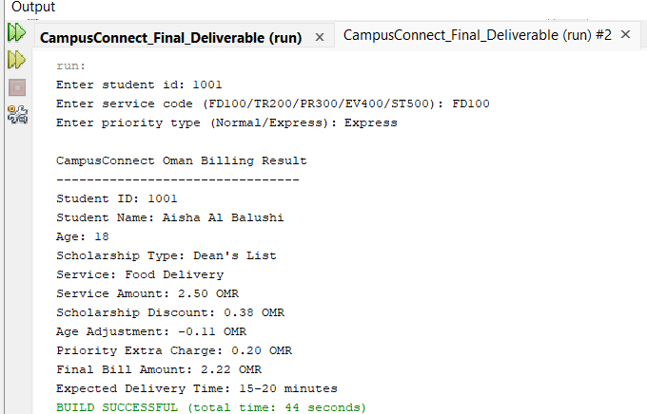

TASK 3: SERVER-SIDE PROGRAM
The server-side program listens for incoming client requests on port 5000. For each accepted client socket, the server creates and starts a ClientHandler thread. The handler reads the request object, retrieves the student and service records through JDBC, calculates the bill, and returns a BillingResponse object to the client.
Server main class:
package campusconnect.server;
import java.net.ServerSocket;
import java.net.Socket;
public class BillingServer {
private static final int PORT = 5000;
public static void main(String[] args) {
try (ServerSocket serverSocket = new ServerSocket(PORT)) {
System.out.println("CampusConnect billing server started on port " + PORT);
while (true) {
Socket clientSocket = serverSocket.accept();
ClientHandler clientHandler = new ClientHandler(clientSocket);
clientHandler.start();
}
} catch (Exception exception) {
System.out.println("Server error: " + exception.getMessage());
}
}
}
Client handler thread:
package campusconnect.server;
import campusconnect.common.BillingRequest;
import campusconnect.common.BillingResponse;
import campusconnect.common.ServiceItem;
import campusconnect.common.Student;
import java.io.ObjectInputStream;
import java.io.ObjectOutputStream;
import java.net.Socket;
public class ClientHandler extends Thread {
private final Socket socket;
private final DatabaseManager databaseManager;
private final BillingCalculator billingCalculator;
public ClientHandler(Socket socket) {
this.socket = socket;
this.databaseManager = new DatabaseManager();
this.billingCalculator = new BillingCalculator();
}
@Override
public void run() {
try (ObjectInputStream input = new ObjectInputStream(socket.getInputStream());
ObjectOutputStream output = new ObjectOutputStream(socket.getOutputStream())) {
BillingRequest request = (BillingRequest) input.readObject();
BillingResponse response = processRequest(request);
output.writeObject(response);
output.flush();
} catch (Exception exception) {
System.out.println("Server client-handler error: " + exception.getMessage());
} finally {
try {
socket.close();
} catch (Exception exception) {
System.out.println("Unable to close socket: " + exception.getMessage());
}
}
}
private BillingResponse processRequest(BillingRequest request) {
try {
Student student = databaseManager.findStudent(request.getStudentId());
if (student == null) {
return BillingResponse.error("Student id not found.");
}
ServiceItem service = databaseManager.findService(request.getServiceCode());
if (service == null) {
return BillingResponse.error("Service code not found.");
}
return billingCalculator.calculate(student, service, request.getPriorityType());
} catch (Exception exception) {
return BillingResponse.error("Unable to calculate bill: " + exception.getMessage());
}
}
}
JDBC database retrieval:
package campusconnect.server;
import campusconnect.common.ServiceItem;
import campusconnect.common.Student;
import java.sql.Connection;
import java.sql.DriverManager;
import java.sql.PreparedStatement;
import java.sql.ResultSet;
import java.sql.SQLException;
public class DatabaseManager {
private static final String URL = "jdbc:mysql://localhost:3306/campusconnect_db";
private static final String USER = "root";
private static final String PASSWORD = "";
public Connection getConnection() throws SQLException {
return DriverManager.getConnection(URL, USER, PASSWORD);
}
public Student findStudent(int id) throws SQLException {
String sql = "SELECT id, name, age, scholarship_type FROM Student WHERE id = ?";
try (Connection connection = getConnection();
PreparedStatement statement = connection.prepareStatement(sql)) {
statement.setInt(1, id);
try (ResultSet resultSet = statement.executeQuery()) {
if (resultSet.next()) {
return new Student(
resultSet.getInt("id"),
resultSet.getString("name"),
resultSet.getInt("age"),
resultSet.getString("scholarship_type"));
}
}
}
return null;
}
public ServiceItem findService(String serviceCode) throws SQLException {
String sql = "SELECT service_code, description, base_fee FROM Service WHERE service_code = ?";
try (Connection connection = getConnection();
PreparedStatement statement = connection.prepareStatement(sql)) {
statement.setString(1, serviceCode);
try (ResultSet resultSet = statement.executeQuery()) {
if (resultSet.next()) {
return new ServiceItem(
resultSet.getString("service_code"),
resultSet.getString("description"),
resultSet.getDouble("base_fee"));
}
}
}
return null;
}
}
Billing calculation rules:
package campusconnect.server;
import campusconnect.common.BillingResponse;
import campusconnect.common.ServiceItem;
import campusconnect.common.Student;
public class BillingCalculator {
public BillingResponse calculate(Student student, ServiceItem service, String priorityType) {
double baseFee = service.getBaseFee();
double scholarshipDiscount = baseFee * getScholarshipRate(student.getScholarshipType());
double amountAfterScholarship = baseFee - scholarshipDiscount;
double ageAdjustment = amountAfterScholarship * getAgeRate(student.getAge());
double amountAfterAge = amountAfterScholarship + ageAdjustment;
double priorityCharge = amountAfterAge * getPriorityRate(priorityType);
double finalAmount = amountAfterAge + priorityCharge;
String deliveryTime = priorityType.equalsIgnoreCase("Express") ? "15-20 minutes" : "30-45 minutes";
return new BillingResponse(true, "Billing calculated successfully", student, service,
scholarshipDiscount, ageAdjustment, priorityCharge, finalAmount, deliveryTime);
}
private double getScholarshipRate(String scholarshipType) {
if (scholarshipType.equalsIgnoreCase("Dean's List")) {
return 0.15;
}
if (scholarshipType.equalsIgnoreCase("Economically Weak")) {
return 0.20;
}
if (scholarshipType.equalsIgnoreCase("Employee Special Support")) {
return 0.10;
}
return 0.0;
}
private double getAgeRate(int age) {
if (age <= 18) {
return -0.05;
}
if (age > 23) {
return 0.05;
}
return 0.0;
}
private double getPriorityRate(String priorityType) {
if (priorityType.equalsIgnoreCase("Express")) {
return 0.10;
}
return 0.0;
}
}

Calculation method used:
- The scholarship discount is calculated from the service base fee.
- The age adjustment is applied after the scholarship discount. A student aged 18 or below receives an additional 5 percent discount, while a student above 23 receives an additional 5 percent charge.
- The Express priority charge is then calculated on the adjusted amount. Normal priority adds no extra charge.
- Expected delivery time is 30-45 minutes for Normal and 15-20 minutes for Express.
Output:
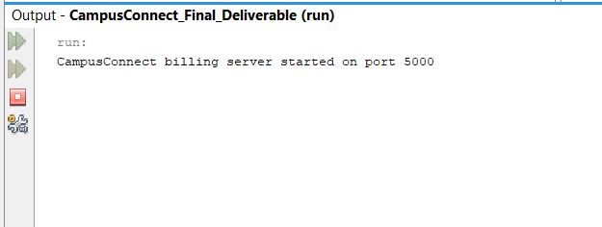

TASK 4: UTILITY CLASS MENU PROGRAM
The utility class task is implemented using ArrayList from the Java Collections Framework. The program allows the user to add a service request, display a request by position, remove a request, and iterate through all requests using Iterator.
Menu-driven Collections program:
package campusconnect.utility;
import java.util.ArrayList;
import java.util.Iterator;
import java.util.Scanner;
public class ServiceCollectionMenu {
private static final ArrayList<String> serviceRequests = new ArrayList<>();
public static void main(String[] args) {
try (Scanner scanner = new Scanner(System.in)) {
int choice;
do {
printMenu();
choice = readChoice(scanner);
switch (choice) {
case 1:
addRequest(scanner);
break;
case 2:
displayRequest(scanner);
break;
case 3:
removeRequest(scanner);
break;
case 4:
displayAllRequests();
break;
case 5:
System.out.println("Exiting utility menu.");
break;
default:
System.out.println("Please choose a valid option.");
}
} while (choice != 5);
}
}
private static void printMenu() {
System.out.println("\nCampusConnect Service Request Menu");
System.out.println("1. Add service request");
System.out.println("2. Display service request by position");
System.out.println("3. Remove service request");
System.out.println("4. Iterate and display all requests");
System.out.println("5. Exit");
System.out.print("Enter choice: ");
}
private static int readChoice(Scanner scanner) {
try {
return Integer.parseInt(scanner.nextLine().trim());
} catch (NumberFormatException exception) {
return -1;
}
}
private static void addRequest(Scanner scanner) {
System.out.print("Enter request details, for example 1001-FD100-Express: ");
String request = scanner.nextLine().trim();
if (request.isEmpty()) {
System.out.println("Request cannot be empty.");
return;
}
serviceRequests.add(request);
System.out.println("Request added successfully.");
}
private static void displayRequest(Scanner scanner) {
System.out.print("Enter position number starting from 1: ");
int index = readChoice(scanner) - 1;
if (index >= 0 && index < serviceRequests.size()) {
System.out.println("Request: " + serviceRequests.get(index));
} else {
System.out.println("Invalid position.");
}
}
private static void removeRequest(Scanner scanner) {
System.out.print("Enter request text to remove: ");
String request = scanner.nextLine().trim();
if (serviceRequests.remove(request)) {
System.out.println("Request removed successfully.");
} else {
System.out.println("Request not found.");
}
}
private static void displayAllRequests() {
if (serviceRequests.isEmpty()) {
System.out.println("No service requests available.");
return;
}
Iterator<String> iterator = serviceRequests.iterator();
int count = 1;
while (iterator.hasNext()) {
System.out.println(count + ". " + iterator.next());
count++;
}
}
}
Key explanation:
- ArrayList is used because it stores multiple service request strings and allows indexed access.
- The add() method stores a new request entered through the keyboard.
- The remove() method deletes a matching request from the collection.
- Iterator is used to display all service requests one by one.

Output:
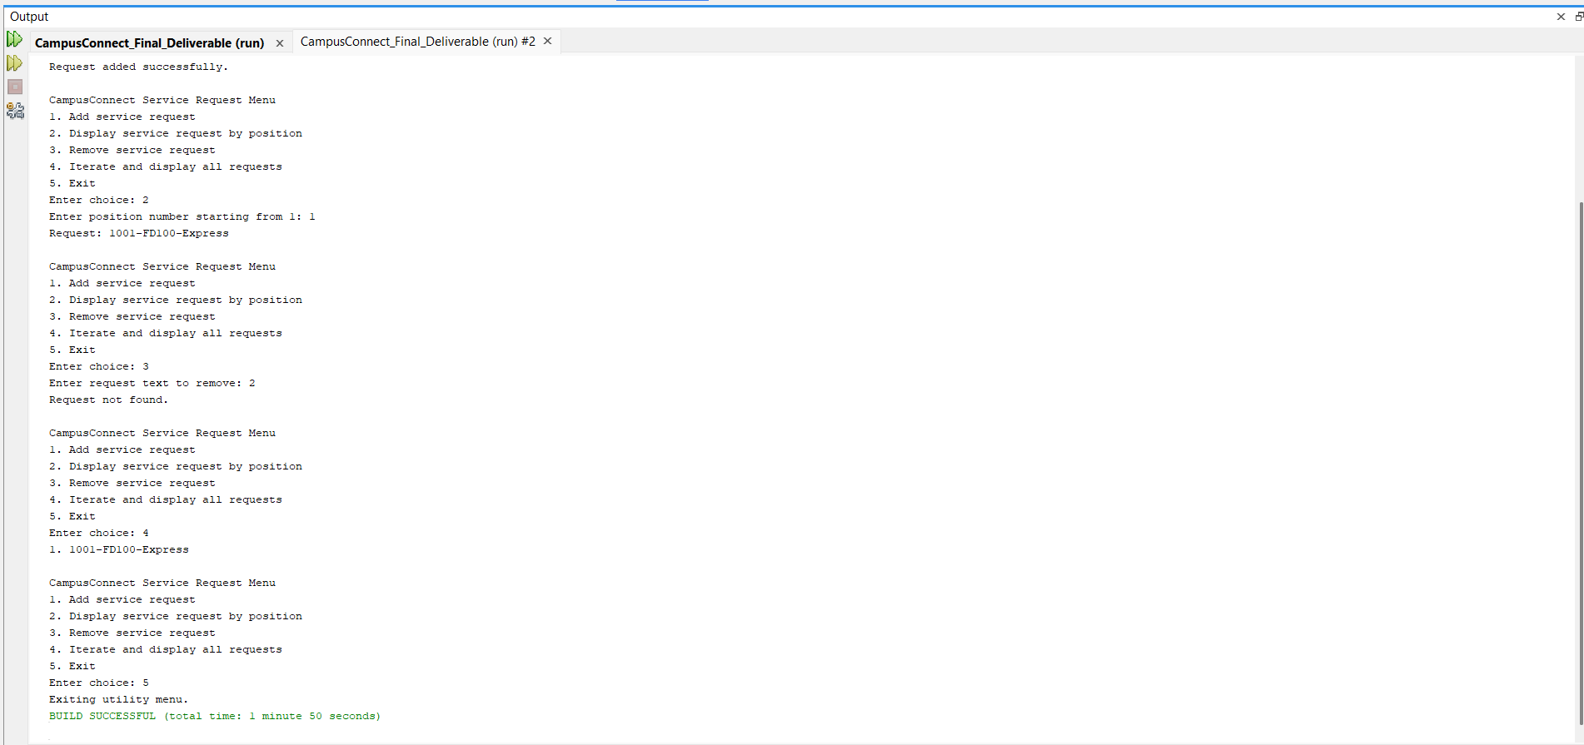

TASK 5: MOOC REFLECTION
Networking in Java is an important concept because it allows two programs to communicate across a network using client-server architecture. In this assignment, the concept was applied by creating a client program and a server program for CampusConnect Oman. The client tells the server the student id, service code and priority type, and then passes this request to the server via a socket connection. The server receives the request and uses the values from the database to process the request, adds up the final bill, and returns the result to the client. The MOOC helped me to understand the workings of Socket and ServerSocket. I also came to know the need of input and output streams as a means of communication between two programs. It was helpful with the assignment as it meant that I could send and receive entire requests and responses as objects rather than just text values. The course also enhanced my knowledge on multithreading in network applications. It is possible for a server to service more than one client so a server with one thread for each client is more flexible. Overall, the MOOC helped me get hands on practical experience with Java networking, and how networking, database access and billing logic can be woven together into one powerful app.

REFERENCES
Oracle. (n.d.). ArrayList (Java Platform SE API specification). https://docs.oracle.com/en/java/javase/22/docs/api/java.base/java/util/ArrayList.html
Oracle. (n.d.). Lesson 1: Socket communications. https://www.oracle.com/java/technologies/jpl2-socket-communication.html
Oracle. (n.d.). PreparedStatement. https://download.oracle.com/otn_hosted_doc/jdeveloper/904preview/jdk14doc/docs/guide/jdbc/getstart/preparedstatement.html
Oracle. (n.d.). Socket (Java Platform SE API specification). https://docs.oracle.com/en/java/javase/11/docs/api/java.base/java/net/Socket.html

